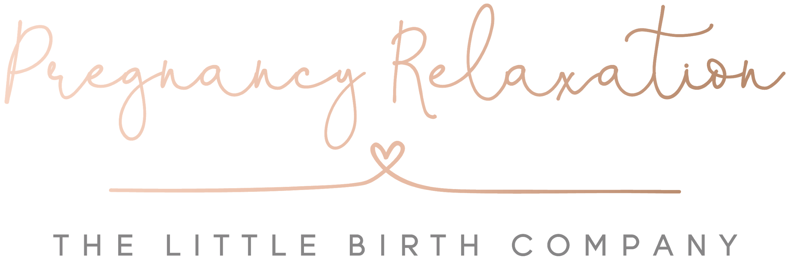

Many thanks for booking a place on The Little Birth Company Pregnancy Relaxation Weekly Classes.

This will be a block of 6 sessions, please select the course dates you would like to attend:

Dates for 2021 as follows:

Jan 7th - Feb 11th
Feb 18th - March 25th
April 1st - May 6th
May 13th - June 17th
June 24th - July 29th
NO COURSE IN AUGUST
Sept 9th - Oct 14th
Oct 21st - Nov 25th
NO COURSE IN DECEMBER

What you will need for the sessions:

Water, Blanket, pillow and anything else to aid your comfort.

I will be in touch prior to your 1st class to confirm details and request payment. Please complete this Booking Form and return to me as soon as possible so your place can be secured.

If you are on Facebook please feel free to join us in The LBC Community Group for all things positive http://bit.ly/TheLBCCommunity
And Birth with Fay’s Facebook page: https://www.facebook.com/birthwithfay

Looking forward to meeting you x

Fay

Booking Form

Please complete:

Name

DOB

Contact Number

Email

Due Date

Birth Order (ie 1st, 2nd, 3rd Child)
Where do you plan to give birth?

Where did you hear about my classes?

Would you be interested in information on my Hypnobirthing Birth Preparation Classes? Yes / No

Anything else you would me to know?

Would you be happy to be in any photographs that I might take during the session that I may share on my website/social media?

